

Tribhuvan University
Faculty of Humanities and Social Sciences
Kirtipur, Kathmandu
A Technical Writing
On
Technical Requirement Document for Webinar.
Submitted by
Name: Bishal Rijal
Roll No: 6 (Six)

Submitted to
Department of Computer Application
In partial fulfilment of the requirements for the Masters in Computer Application

Patan Multiple Campus
Patandhoka, Lalitpur

Supervisor
Roshan Tandukar

………………...

ABSTRACT
Webinars have become a standard channel for teaching, product communication, recruitment and internal meetings. Although they appear simple to attendees, a successful webinar depends on a chain of technical components: registration, streaming, presenter equipment, network capacity, moderation, recording, security and analytics. When these components are left unspecified, failures occur live, in front of the audience.
This report examines the Technical Requirements Document (TRD) as a tool for preventing such failures. It explains the purpose and audience of a webinar TRD, proposes a fourteen-part structure, and shows how to write functional and non-functional requirements that are measurable and testable. It also covers presenter and production standards, network and infrastructure needs, integrations, security and privacy controls, rehearsal and acceptance testing, risk management and post-event deliverables.
The report concludes that a concise, versioned and testable TRD, written before platform selection, reduces live-event risk, shortens vendor evaluation and gives all stakeholders a shared definition of success. A reusable template is provided in Appendix A.
TABLE OF CONTENTS

ABSTRACT i
LIST OF ABBREVIATIONS iii
CHAPTER 1: INTRODUCTION 1
1.1Problem Statement 1
1.2 Objectives 1
1.3 Scope and Limitations 1
CHAPTER 2: OVERVIEW OF WEBINAR SYSTEMS AND THE TRD 2
2.1 Anatomy of a Webinar System 2
2.2 What Is a Technical Requirements Document? 2
2.3 Purpose and Audience 2
2.4 Benefits of a TRD 3
CHAPTER 3: STRUCTURE OF A WEBINAR TRD 4
3.1 Recommended Structure 4
3.2 Overview, Objectives and Scope 4
3.3 Assumptions and Constraints 4
3.4 Stakeholders and Roles 4
CHAPTER 4: REQUIREMENTS SPECIFICATION 6
4.1 Functional Requirements 6
4.2 Non-Functional Requirements 6
4.3 Presenter and Production Requirements 7
4.4 Network and Infrastructure Requirements 9
CHAPTER 5: INTEGRATIONS AND SECURITY 10
5.1 Integrations and Data Flow 10
5.2 Security, Privacy and Compliance 10
CHAPTER 6: VERIFICATION, RISK AND POST-EVENT ACTIVITIES 11
6.1 Testing and Rehearsal 11
6.2 Acceptance Criteria 11
6.3 Risks and Contingency Plan 12
6.4 Post-Event Requirements 12
CHAPTER 7: CONCLUSION 13
REFERENCES 14

LIST OF ABBREVIATIONS
Abbreviation |  |  |  |  | Full Form
API |  |  |  |  | Application Programming Interface
CCPA |  |  |  |  | California Consumer Privacy Act
CRM |  |  |  |  | Customer Relationship Management
FR |  |  |  |  | Functional Requirement
GDPR |  |  |  |  | General Data Protection Regulation
HD |  |  |  |  | High Definition
HTTPS |  |  |  |  | Hypertext Transfer Protocol Secure
IT |  |  |  |  | Information Technology
Mbps |  |  |  |  | Megabits per Second
NFR |  |  |  |  | Non-Functional Requirement
SSO |  |  |  |  | Single Sign-On
TCP |  |  |  |  | Transmission Control Protocol
TLS |  |  |  |  | Transport Layer Security
TRD |  |  |  |  | Technical Requirements Document
UDP |  |  |  |  | User Datagram Protocol
USB |  |  |  |  | Universal Serial Bus
VLAN |  |  |  |  | Virtual Local Area Network
WCAG |  |  |  |  | Web Content Accessibility Guidelines
XLR |  |  |  |  | X series connector, Latch, and Rubber

CHAPTER 1: INTRODUCTION

1.1Problem Statement
Webinar planning is frequently driven by the features of a chosen platform instead of by clearly stated needs. Assumptions about capacity, presenter equipment, network access, accessibility and data handling remain unrecorded, so problems are discovered during the live session or after it. There is a need for a single, agreed document that states what the webinar must technically do, under what conditions, and how success will be verified.

1.2 Objectives
The objectives of this report are to:
- Explain what a Technical Requirements Document (TRD) for a webinar is and who uses it,
- Propose a practical structure for a webinar TRD,
- show how to write functional and non-functional requirements that are measurable and testable,
- Describe the verification, risk-management and post-event activities that the TRD should control, and
- Provide a reusable template that practitioners can adapt.

1.3 Scope and Limitations
The report covers the technical planning of single-session webinars delivered through a commercial or enterprise webinar platform. It does not cover content design, slide creation, advertising or marketing campaigns. Numerical values used in examples, such as capacity targets and delivery times, are illustrative and must be adjusted to the needs of each event and the limits of the chosen platform.

CHAPTER 2: OVERVIEW OF WEBINAR SYSTEMS AND THE TRD

2.1 Anatomy of a Webinar System
A webinar system consists of several cooperating components. Attendees reach a registration page, which passes their details to the webinar platform. The platform sends confirmation and reminder emails, streams the live session to attendees, stores the recording for later replay, and passes attendance data to analytics and customer-relationship systems.
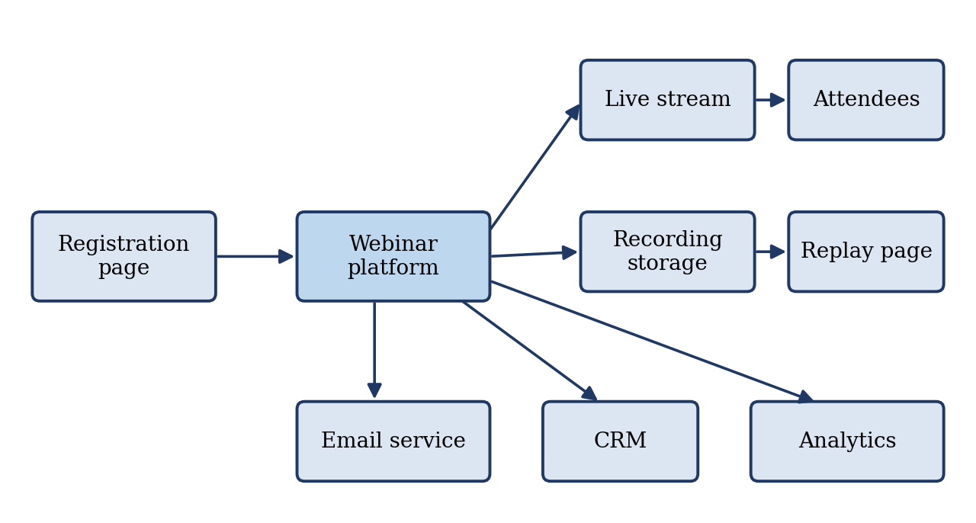
Figure 1: Typical webinar system architecture and data flow

2.2 What Is a Technical Requirements Document?
A Technical Requirements Document is a formal statement of what a system must do and the conditions under which it must do it. For a webinar, the TRD defines the technical behavior of the event, including registration, live delivery, interaction, recording, security, integrations and verification. It is written before platform selection or set-up begins and serves as the reference for decisions, testing and acceptance.

2.3 Purpose and Audience
A webinar TRD is read by many people, each with different concerns. Table 1 lists the main readers and what each needs from the document.
Table 1: Intended readers of the webinar TRD
Reader | What they need from the TRD
Event owner / marketing | Confirmation that business goals (registrations, leads, replays) are technically supported
Producer / moderator | Controls, roles and run-of-show constraints
IT / network team | Bandwidth, firewall, single sign-on and device requirements
Security / compliance | Data handling, consent, retention and access control
Presenters | Equipment, software and rehearsal expectations
Vendor / platform team | Unambiguous acceptance criteria

2.4 Benefits of a TRD
A well-written TRD turns assumptions into agreements. It exposes capacity and accessibility needs early, prevents platform features from dictating the event design, gives the vendor clear acceptance criteria, and provides a baseline against which changes can be controlled. After the event it supports a structured review of what worked and what did not.

CHAPTER 3: STRUCTURE OF A WEBINAR TRD

3.1 Recommended Structure
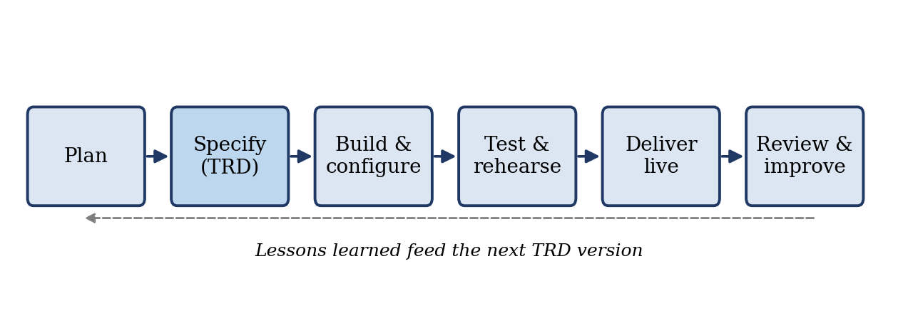
Figure 2: Webinar life cycle with the TRD at the specification stage

3.2 Overview, Objectives and Scope
The overview states the title, date and time (with time zones), expected audience size, format and business goal. Goals drive technical choices, a lead-generation webinar needs CRM integration, whereas an internal town hall may need single sign-on and no public registration. An example overview reads, “Quarterly product update webinar for 2,000 customers, 60 minutes, three presenters, live Q&A, on-demand replay available within 24 hours.”
The scope lists what the TRD covers and what it does not. Typical in-scope items are the registration page, live streaming, chat and Q&A, polls, recording, reminder emails and attendance reporting. Content creation, slide design and paid advertising are usually out of scope.

3.3 Assumptions and Constraints
Assumptions are things believed to be true but not yet verified, for example that all presenters will join from wired connections. Constraints are fixed limits, for example that the platform must be approved by the security team or that licensing cost per attendee is capped. Recording both allows them to be challenged early, when changing them is still inexpensive.

3.4 Stakeholders and Roles
The TRD defines who does what on the day of the event, together with the platform permissions each role needs. Typical roles are:
- Host / event owner: accountable for the event as a whole.
- Producer: controls the stage, scenes and recording.
- Moderator: manages questions and chat.
- Presenters: deliver the content.
- Technical support: handles attendee and presenter problems.

Permissions should be explicit. For example, presenters may share their screen, while moderators may approve questions but may not start or stop the recording.

CHAPTER 4: REQUIREMENTS SPECIFICATION

4.1 Functional Requirements
Functional requirements describe what the system does. They are grouped by phase: registration, the live session, and recording and replay. Each requirement has a unique identifier so that it can be traced to a test and to any later change. Table 2 gives an example set.
Table 2: Example functional requirements for a webinar
ID | Phase | Requirement
FR-01 | Registration | The system shall provide a registration form capturing name, email, company and role.
FR-02 | Registration | The system shall send a confirmation email with a unique join link and calendar invitation within 5 minutes of registration.
FR-03 | Registration | The system shall send reminders 24 hours and 1 hour before the event.
FR-10 | Live session | The platform shall support simultaneous presenter video, audio and screen sharing.
FR-11 | Live session | Attendees shall be able to join from a browser without installing software.
FR-12 | Live session | The platform shall provide a Q&A panel where attendees can submit and up-vote questions.
FR-13 | Live session | The moderator shall be able to publish, answer privately or dismiss questions.
FR-14 | Live session | The platform shall support at least three live polls with real-time results.
FR-15 | Live session | The platform shall provide live closed captions.
FR-20 | Recording | The platform shall record the full session in at least 1080p with audio.
FR-21 | Recording | The recording shall be available to the host within 2 hours of the session ending.
FR-22 | Recording | The replay link shall be emailed to registrants and no-shows within 24 hours.

4.2 Non-Functional Requirements
Non-functional requirements define quality attributes such as capacity, delay, availability, accessibility and compatibility. Many webinar failures originate here, so each requirement must be measurable. Table 3 lists examples.
Table 3: Example non-functional requirements for a webinar
ID | Category | Requirement
NFR-01 | Capacity | Support at least 3,000 concurrent attendees (50% headroom above 2,000 expected).
NFR-02 | Latency | End-to-end stream delay shall not exceed 15 seconds.
NFR-03 | Availability | Platform uptime of 99.9% during the event window.
NFR-04 | Video quality | Adaptive bitrate from 360p to 1080p.
NFR-05 | Accessibility | Conform to WCAG 2.1 AA for the registration page and player controls.
NFR-06 | Compatibility | Latest two versions of Chrome, Edge, Firefox and Safari, and iOS and Android browsers.
NFR-07 | Localizations | Registration page and emails in English.
NFR-08 | Scalability | Registration page shall handle 200 submissions per minute without errors.

4.3 Presenter and Production Requirements
Presenters are often the weakest link in a live event, so the TRD specifies a minimum set-up:
Hardware Requirements
Computer/Laptop
- A laptop or desktop computer with a current operating system such as Windows 10/11 or macOS is recommended.
- The device should have at least 4 to 8 GB of RAM and a modern multi-core processor to handle video conferencing, presentation software, screen sharing, and other required applications simultaneously.
- The computer should have sufficient free storage space for presentation files, supporting materials, and any required software.
- The device must have at least one available USB port for connecting external audio or other accessories.
- Presenters should connect the laptop to AC power throughout the event. Do not rely only on battery power.
- Automatic system updates, restarts, or sleep settings should be disabled during the presentation period.

Internet Connection
- A wired Ethernet connection is preferred for greater stability.
- A minimum upload speed of 100 Mbps is recommended and should be tested before the event.
- If Wi-Fi must be used, the presenter should connect to a stable 5 GHz network and remain close to the router.
- Public Wi-Fi networks should be avoided because they may have unstable speeds and security limitations.
- The internet connection should be tested from the same location and device that will be used during the event.
Microphone and Audio
- A USB or XLR microphone, professional headset, or equivalent external microphone is required.
- Built-in laptop microphones are not acceptable because they can capture keyboard noise, room echo, and background sounds.
- The microphone should be positioned at an appropriate distance from the presenter to maintain consistent audio levels.
- A short audio test should be completed before the event to check volume, clarity, background noise, and possible echo.
- Presenters using an XLR microphone should have the required audio interface or mixer available and tested in advance.
- Wired headphones or headsets are recommended where possible to reduce audio delay and feedback.
Camera
- A 1080p webcam is recommended for presenters.
- The camera should be positioned at approximately eye level and should provide a clear view of the presenter.
- The camera lens should be clean and unobstructed.
- Front-facing lighting should illuminate the presenter evenly. Strong light sources directly behind the presenter should be avoided.
- The camera should remain stable throughout the presentation rather than being handheld.

Display and Second Monitor
- The primary display should be large enough to comfortably view presentation slides, the event platform, and technical instructions.
- A second monitor is recommended for viewing presenter notes, chat messages, event controls, or technical instructions while keeping the main presentation screen clear.
- If a second monitor is unavailable, a tablet or secondary device may be used for notes and communication.
Power and Backup Equipment
- The laptop should remain connected to a reliable power source during the event.
- A power bank or UPS should be available where power interruptions are possible.
- Presenters should keep essential charging cables and adapters readily accessible.
- A backup device, such as a smartphone or secondary laptop, should be fully charged and ready for use.
- A second internet connection, such as a mobile hotspot from a different network, should be prepared as a backup.

4.4 Network and Infrastructure Requirements
For corporate and on-site events the network team needs exact figures. Each attendee typically needs about 300 to 500 Mbps of download bandwidth for HD video. The platform’s domains and ports, typically HTTPS on port 443 and TCP or UDP ports for real-time media, must be added to the firewall allow-list; the vendor should supply this list as an appendix.
For large internal audiences, an enterprise content delivery network or multicast solution prevents the office internet link from becoming saturated. An on-site studio should have a dedicated VLAN or wired line, an uninterruptible power supply and a secondary internet connection.

CHAPTER 5: INTEGRATIONS AND SECURITY

5.1 Integrations and Data Flow
Each integration should be documented with its direction, the data fields exchanged and the event that triggers the exchange. Table 4 summarizes the common integrations; the overall flow was shown earlier in Figure 1.
Table 4: Common webinar integrations
System | Direction | Data | Trigger
CRM | Platform to CRM | Registrant, attendance, poll answers | Registration; post-event sync
Email service | Platform to email | Confirmation, reminders, replay link | Registration and schedule
SSO / identity provider | Bidirectional | Authentication token | Join (internal events)
Analytics | Platform to analytics | Page views, drop-off, watch time | Real time
Video hosting | Platform to host | Recording file | Post-event

5.2 Security, Privacy and Compliance
Security requirements protect both the audience and the presenters. The TRD should state at least the following:
- Access control: unique join links or single sign-on, an optional passcode, and a locked attendee list 15 minutes after the start for private events.
- Encryption: TLS 1.2 or higher in transit and encryption at rest for recordings.
- Presenter safeguards: attendees muted and video-off by default, and screen sharing restricted to presenters.
- Privacy: explicit consent for recording and data capture on the registration form, with a link to the privacy policy.
- Regulation: compliance with applicable regimes such as GDPR or CCPA, including data residency where required.
- Retention: a defined period, for example 12 months, after which recordings and attendee data are deleted.
- Moderation: a profanity filter and the ability to remove a disruptive attendee immediately.

CHAPTER 6: VERIFICATION, RISK AND POST-EVENT ACTIVITIES

6.1 Testing and Rehearsal
A requirement is useful only if it can be verified. Each major requirement is therefore paired with a test, scheduled relative to the event date as shown in Figure 3 and described in Table
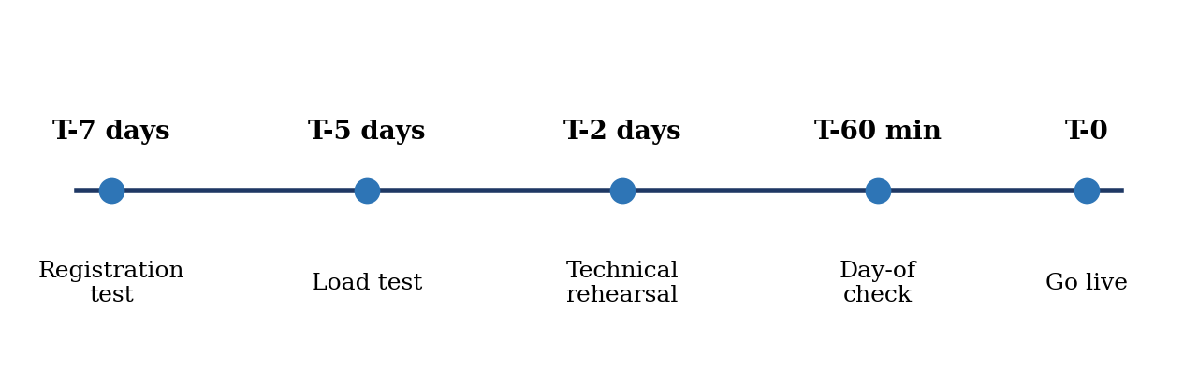
Figure 3: Test and rehearsal timeline before the event
Table 5: Test plan and pass criteria
Test | When | Pass criteria
Registration end-to-end | T-7 days | Form submits, email arrives within 5 minutes, calendar invitation opens correctly
Load test | T-5 days | 3,000 simulated viewers with no more than 1% buffering rate
Technical rehearsal | T-2 days | All presenters connect, share screens and switch scenes without errors
Q&A and poll dry run | T-2 days | Moderator publishes and answers questions; poll results display correctly
Day-of check | T-60 minutes | Audio and video working, recording started, captions on, backup presenter ready

6.2 Acceptance Criteria
Acceptance criteria state when the event is considered technically successful. For example: the live session runs for its full duration with no more than 30 seconds of cumulative interruption, the recording is delivered within 2 hours, and the attendance report matches platform logs within a 2% variance.

6.3 Risks and Contingency Plan
Risks are identified in advance, rated by likelihood and impact, and given a mitigation. Table 6 lists common webinar risks. The TRD should also define an escalation path, stating who decides to pause, switch to a backup or end the event, and include a template message for informing attendees of delays.
Table 6: Common webinar risks and mitigations
Risk | Likelihood | Impact | Mitigation
Presenter loses connection | Medium | High | Backup device and network; producer plays a pre-recorded segment
Platform outage | Low | Critical | Secondary stream on an alternative platform; pre-drafted attendee message
Audio problems | Medium | High | Pre-event audio check; backup microphone
Attendance above capacity | Low | High | Capacity headroom; waiting-room feature
Disruptive attendee | Low | Medium | Moderation controls; attendees muted by default
Recording fails | Low | High | Parallel local recording on the producer’s machine

6.4 Post-Event Requirements
The TRD also governs what happens after the live session: the recording is edited and published within 24 hours, an engagement report covering registrants, attendees, average watch time and poll and Q&A summaries is delivered within 48 hours, unanswered questions are exported and routed to the responsible team, data is synchronized to the CRM and verified, and a retrospective is held within one week to record lessons learned.

CHAPTER 7: CONCLUSION
A webinar TRD turns assumptions into agreements. By defining functional behavior, measurable quality targets, presenter and network standards, security controls and acceptance tests in advance, teams reduce live-event risk, shorten vendor evaluation and give every stakeholder a shared definition of success. The document should be kept concise, versioned and reviewed after each event, so that it improves with every webinar it supports.

REFERENCES
European Parliament and Council (2016) Regulation (EU) 2016/679 (General Data Protection Regulation). Official Journal of the European Union, L 119.
International Organization for Standardization, International Electrotechnical Commission and Institute of Electrical and Electronics Engineers (2018) ISO/IEC/IEEE 29148:2018: Systems and software engineering – Life cycle processes – Requirements engineering. Geneva: ISO/IEC/IEEE.
Wiegers, K. and Beatty, J. (2013) Software Requirements. 3rd edn. Redmond, WA: Microsoft Press.
World Wide Web Consortium (2018) Web Content Accessibility Guidelines (WCAG) 2.1. W3C Recommendation.

